Alcohol Use in New Mexico
Adult Heavy Drinking

New Mexico Statewide Epidemiological Outcomes Workgroup
White Paper Series

November 16, 2017
Produced by Coop Consulting, Inc. on behalf of the
New Mexico Statewide Epidemiological Outcomes Workgroup
Mission New Mexico’s Statewide Epidemiological and Outcomes Workgroup (SEOW) reviews and disseminates data about substance abuse and misuse and their consequences. It also identifies best practice information about evidence-based prevention strategies, policies and practices that can lead to successful outcomes for New Mexicans. The purpose of this two-fold work is to inform communities so that they can better target behaviors and risk factors that can be positively impacted by the implementation of well-chosen, evidence-based prevention approaches that are appropriate for the population. The important work of the SEOW is directed by the Office of Substance Abuse Prevention (Behavioral Health Services Division, Human Services Department) and supported by federal funding from the Center for Substance Abuse Prevention, Substance Abuse and Mental Health Services Administration.

Statewide Epidemiology and Outcomes Workgroup (SEOW) Members
BHSD Office of Substance Abuse Prevention  Karen Cheman, Prevention Director,  NPN & SEOW Director  Heather Burnham, Program Manager  Antonette Silva-Jose, Program Manager  Anwar Walker, Program Manager | Behavioral Health Services Division (BHSD)  Wayne Lindstrom, Ph.D., Director and CEO, Behavioral Health Collaborative  Mika Tari, Deputy Director  Tiffany Wynn, Clinical Services Director
Department of Finance and Administration  Julie Krupcale, DWI Bureau Chief | Children Youth and Families Department, Behavioral Health Services  Michael Hock, Program Manager
DOH Epidemiology and Response Division  Jim Davis, Epidemiologist  Dan Green, Epidemiologist  Kathryn Lowerre, Program Evaluator  Ihsan Mahdi, Epidemiologist  Annaliese Mayette, Epidemiologist  Carol Moss, Epidemiologist  Luigi Garcia Saavedra, Epidemiologist  Laura Tomedi, Epidemiologist | Community Members*  Ann DelVecchio, Owner, Alpha Assessment Associates  Shelley Moeller, Program Planner & Evaluator, M&O Consulting  John Steiner, Program Manager, UNM CASAA/COSAP  Sharz Weeks, Program Specialist, Bernalillo County Community Health Council
Pacific Institute for Research & Evaluation (PIRE), NM State Level Evaluator  Liz Lilliott, Ph.D  Martha Waller, Ph.D  Lei Zhang, Ph.D | Coop Consulting, Inc., Project Staff  Michael Coop  Andrea Niehaus  Tina Ruiz  Tim Werwath
*Community preventionists across the state attend and contribute using the SEOW as a resource for work in the larger New Mexico prevention system. For more information, contact Karen Cheman, karen.cheman@state.nm.us or Michael Coop, michaelcoop@newmexico.com.

Introduction

Alcohol consumption is high in most Western countries, although the United States ranks far below others such as France, Germany, and the United Kingdom. Nevertheless, the 2015-2016 National Survey of Drug Use and Health estimates that approximately 14.8 million American adults have an alcohol use disorder, or approximately 6.1% of the U.S. population. In New Mexico, there are an estimated 155,000 adults with an alcohol use disorder, or 7.4% of the state’s population. In this paper, we explore the leading cause of chronic alcohol-related disease in adults, long-term heavy drinking.

How is adult heavy drinking defined, and what are its consequences?

An alcohol use disorder is more broadly defined as a pattern of alcohol use that involves problems controlling one’s drinking and continuing to use alcohol even when it causes social and health issues. This generally includes both regular binge drinking (having five or more drinks on one occasion) and long-term heavy drinking.

Heavy drinking is defined as having more than two drinks daily for men, or more than one drink daily for women. This type of drinking (as opposed to binge drinking) is considered primarily responsible for the incidence and progression of chronic alcohol-related diseases, such as alcoholic liver disease. Long-term heavy drinking is associated with the development of alcohol dependence and other social problems such as lost productivity and unemployment.

In general, the greater the amount and longer duration of alcohol use the more likely alcohol-related chronic diseases will develop. However, the amount of alcohol consumed before alcohol-related chronic diseases develop is extremely variable, with some people being extremely sensitive to the effects of alcohol and others being less vulnerable to its harmful effects. On average, having six or more drinks of alcohol daily will lead to cirrhosis of the liver in 10 years for men and 5 years for women.

What are the risk factors for heavy drinking?

Data from the 2016 Behavioral Risk Factor Surveillance System (BRFSS) indicate that in the United States overall, men tend to have higher rates of heavy drinking than women (6.3% versus 5.5%). Rates of heavy drinking tend to be highest among those 18-24 (6.7%), with rates steadily declining as individuals age and dramatically declining after age 64. Compared to those who are married, heavy drinking is highest among those who were never married or are divorced (5.4% versus 7.3% and 5.7%, respectively).

With respect to employment and education, heaving drinking is higher among those who are employed compared to those who are unemployed or unable to work (7.0 % versus 5.6% and 3.3%, respectively). Rates of heavy drinking tend to increase with income level, with those making $75,000 per year or more having the highest rate of heavy drinking (7.5% versus 5.1% for those making less than $10,000 per year). Rates of heavy drinking are also higher among those with a college degree (6.1% versus 4.9% for those without a high school degree).

Other psychosocial risk factors for the development of an alcohol use disorder characterized by long-term heavy drinking include:
- Family history – A family history of alcohol use disorders is a well-established risk factor for the development of one. However, not all children of alcoholics develop an alcohol use disorder. A family history of alcoholism is more likely to contribute to the development of an alcohol use disorder in a person if it occurs in families that also exhibit high levels of familial antisocial personality disorder and familial violence.
- Anxiety and/or depression – One of the most commonly studied risk factors for the development of alcohol use disorders involves alcohol’s ability to reduce anxiety, thus making it a relatively easy way to cope with stress. Evidence suggests that the strongest relationship between stress and drinking occurs in individuals who experience anxiety and/or depression and have a coping style characterized by avoiding rather than confronting life issues.
- Attitudes towards alcohol – The associations individuals make with and the beliefs they hold about alcohol are associated with the development of alcohol use disorders. Some hypothesize that conscious, explicit expectations influence alcohol use through the deliberate decision to drink alcohol (i.e., drinking to “blow off steam”). Others hypothesize that unconscious memory associations may influence alcohol use as well, especially when the expectations are triggered by a specific environment (i.e., being at a bar with friends).
What is the prevalence of and what are the trends in heavy drinking?
Data from the Behavioral Risk Factor Surveillance System (BRFSS) estimate that in 2016, 5.5% of New Mexicans 18 and older met the criteria for heavy drinking. This is actually considerably lower than other states, as New Mexico ranks 40th out of the 50 states (see Map 1).
Map 1. Prevalence of heavy drinking among adults 18 and older by state, 2016
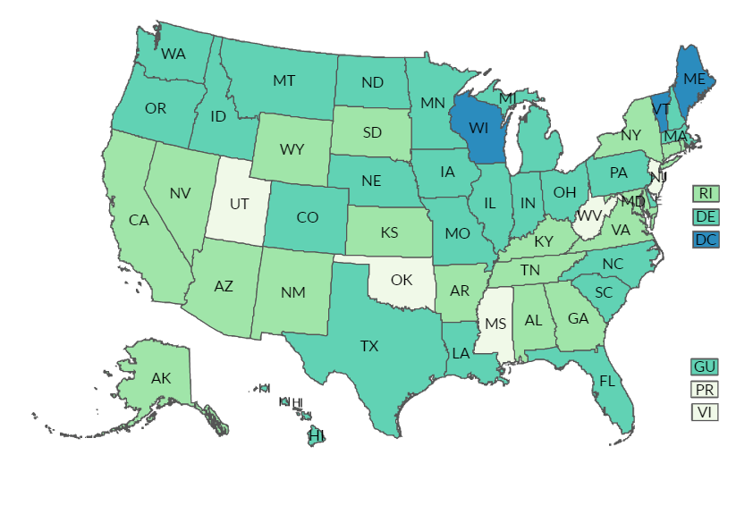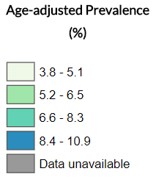
Source: Centers for Disease Control and Prevention, BRFSS Prevalence & Trends Data

As can be seen in Chart 1, rates of heavy drinking in New Mexico have been relatively constant since 2005.
Chart 1. Prevalence of heavy drinking among adults 18 and older in New Mexico, 1998-2016
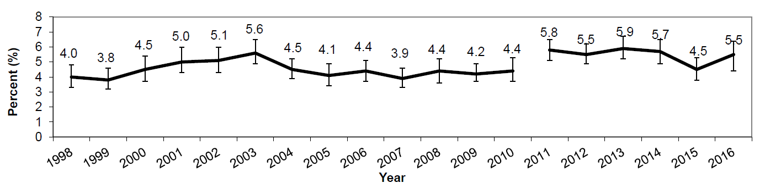
Source: New Mexico Department of Health, Epidemiology and Response Division
Table 1 breaks down heavy drinking rates by age, sex, and race/ethnicity in New Mexico. Overall, men tend to have higher rates of heavy drinking than women (6.3% versus 4.3%). Rates of heavy drinking are highest among American Indian and Hispanic males (7.0% and 6.7%, respectively). Among females, rates of heavy drinking are highest among Black and White women (11.7% and 6.5%, respectively). With respect to age, rates of heavy drinking are highest among individuals 25-64 (5.8%).
Table 1. Prevalence of heavy drinking among adults 18 and older in New Mexico by age, race/ethnicity, and gender, 2014-2016
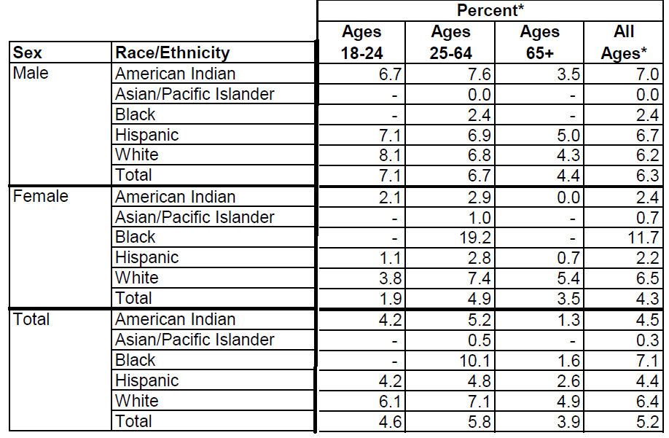
Source: New Mexico Department of Health, Epidemiology and Response Division

Map 2 (see next page) shows the breakdown of heavy drinking rates by county in New Mexico (note that data are not available for all 33 counties due to small sample sizes). Heavy drinking rates are highest in Hidalgo (11.7%), Catron (7.9%), and Lincoln (7.5%) counties. It should be noted that this is in contrast to rates of alcohol-related death (not shown), which are highest in the northwestern counties of Rio Arriba, McKinley, and Cibola.

Conclusion
While heavy drinking is not as prevalent in New Mexico as it is in other parts of the United States, it remains a serious public health issue as it is the primary contributing factor to alcohol-related death, of which New Mexico has the highest rate in the entire nation. Reducing heavy drinking will help to significantly reduce rates of alcohol-related death in the state. It is critical for public health efforts concerning alcohol to address what heavy drinking is, how it progresses, and what the risk factors are for developing an alcohol use disorder. Such efforts may include broader public education campaigns about the risks of excessive alcohol consumption, its physical and mental health consequences, and treatment options for individuals with an alcohol use disorder.
Map 2. Prevalence of heavy drinking among adults 18 and older in New Mexico by county, 2014-2016
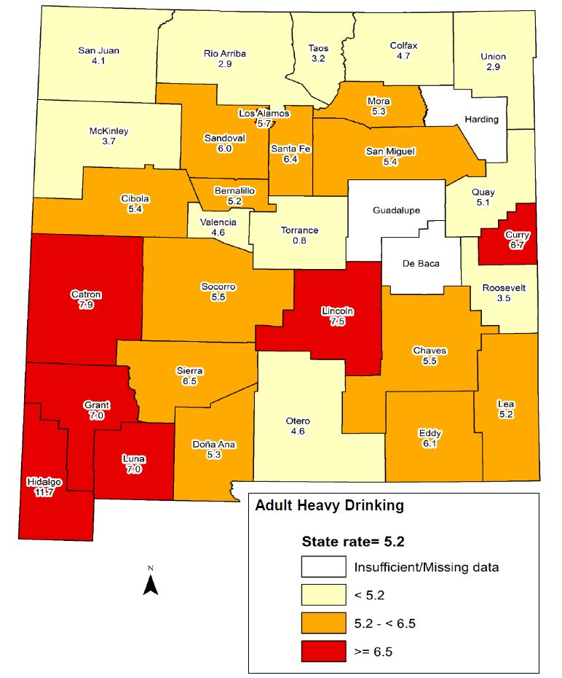
Source: New Mexico Department of Health, Epidemiology and Response Division

World Health Organization. Global Status Report on Alcohol and Health, 2014.
Substance Abuse and Mental Health Services Administration. 2015-2016 NSDUH State Estimates of Substance Use and Mental Disorders, 2018.
Booth, Brenda M., and Weiwei Feng. "The impact of drinking and drinking consequences on short-term employment outcomes in at-risk drinkers in six southern states." Journal of Behavioral Health Services and Research 29.2 (2002): 157-166.
American College of Gastroenterology, Alcoholic Liver Disease: A Consumer Health Guide, 2010.
Zucker, Robert A., Gayle M. Boyd, and Jan Howard, eds. The Development of Alcohol Problems: Exploring the Biopsychosocial Matrix of Risk. No. 94. US Department of Health and Human Services, Public Health Service, National Institutes of Health, National Institute on Alcohol Abuse and Alcoholism, 1994.
Finn, Peter R., et al. "Heterogeneity in the families of sons of alcoholics: The impact of familial vulnerability type on offspring characteristics." Journal of Abnormal Psychology 106.1 (1997): 26.
U.S. Department of Health and Human Services, National Institute on Alcohol Abuse Alcoholism. Ninth Special Report to the U.S. Congress on Alcohol and Health, 1997.
Kushner, Matt G., et al. "Anxiety and Drinking Behavior: Moderating Effects of Tension‐Reduction Alcohol Outcome Expectancies." Alcoholism: Clinical and Experimental Research 18.4 (1994): 852.
Stacy, Alan W. "Memory activation and expectancy as prospective predictors of alcohol and marijuana use." Journal of Abnormal Psychology 106.1 (1997): 61.
It should be noted that beginning 2011, the Behavioral Risk Factor Surveillance System updated its surveillance methods, and therefore data changes between 2010 and 2011 should be interpreted with caution. These methodological updates in 2011 included adding cell phones to their phone-based survey sample and adding improved statistical techniques.

